**ABSTRACT**

In the progressing world of technology, people’s awareness for health importance is increasing. So, a complete health care System is needed in every person’s life. Although “the people” are contesting in the health life as gyms, their ability to monitor the progress in their bodies is somehow weak. A System that offers an advanced health advice both at gym and home, as well as tracking the improvement is needed. This paper analyzes the requirements of Fitness and Health Care System and attempts to apply the Requirements Engineering process. Functional Requirements, Nonfunctional requirements, and System models will also be dealt with.

# Keywords

Fitness & Health Care Systems, Software Requirements

Engineering, Requirements Modelling.

# I. INTRODUCTION

Fitness & health care is a vital demand for a growing number of people whether they have health problems or simply want to have a good shape. A number of factors have combined to significantly alter the approach for gyms and health improvement. Starting with their day from home, moving to different types of living, back into their bed, every daily specs must be set under surveillance for monitoring and advanced health guidance [1].

The progressing technology in our lives has its own dark side. Although it led to an easier way of living, this went on the cost of our health and bodies [2]. A US study shows that people spend up to 10 hours on the internet, they most probably are on a social networking websites or just watching videos. The main cause of laziness is most probably the internet. By having internet, people tend to rely on it far too much. If they don’t know an answer to something, the most logical thing to do is go on Google. People are not using their brain cells because of the internet. That is a big disadvantage of technology. People are not using their brains and relying too much on technology to do everything for them [3]. On the other hand, this system will take advantage of this fact to help people change their lifestyle.

A daily feedback of a person’s life can help the **EXPERTS (trainers at the gym, & nutritionist)** to track his daily food and his nutrition system overall. Which means he will be under supervision all the time that’ll help to customize his training sets at the gym as well as his nutrition at home.

Based on what has been mentioned above, it is very demanding to develop a software system for Fitness & Health Care. **The Software to be designed is based on a real case system of Capoeira Cordão de Ouro School, that is located in Beit Safafa, Jerusalem.**

**The school’s headmaster is Coach Hamza Hirbawi, and it has several coaches in the school.**

**The Capoeira School is growing daily through the Arabic region in East Jerusalem and the West Bank, just as Ras-Alamoud, Silwan, Attur, Beit Hanina, Kufur Akab, Ramallah, Shu’fat Camp and Beit Lahim.**

**The current system uses only papers, phones, Facebook and WhatsApp for connection in the meantime. But is eagerly looking forward for a new Software System to help the improvement and the growing of this School which’ll be done in this project.**

Requirements Engineering (RE) is the first key sub-process following the conclusion of a statement of need. It has to do with the identification of goals to be accomplished by the potential system, the filtering out of such goals and manipulating them to determine the specifications and system models. Software requirements characterize what should be done to satisfy the needs of the stakeholders. Software requirements must satisfy the stakeholders’ needs to ensure the right system is later developed. The process by which these needs are identified is referred to as requirements engineering (RE). In order for the requirements engineering process to be successful, it must not only recognize the needs of customers and users, but it must exhibit further understanding of the context in which the software will run. There are a number of techniques for developing requirements specifications. These include structured, object-oriented, algebraic specification, prototyping, and domain model methods [4].

A critical issue here is to understand user requirements. Misunderstanding of requirements among software developers and stakeholders will trigger problems in satisfying needs, isolating and fixing defects, and estimating costs and schedules during the software development process [5].

Functional Requirements are the domain specific capabilities of the system. They represent what the developed system will do without any regards to how it should be done. Nonfunctional Requirements are the constraints placed on the functional requirements, or quality requirements. These include a variety of properties including performance, policy constraints, safety, privacy, reliability and security [6].

There are a number of techniques to modeling, representing, and checking requirements. In this phase, the use case diagram is the one mentioned. A use case diagram is a dynamic or behavior diagram in [UML](https://www.smartdraw.com/uml-diagram/). Use case diagrams model the functionality of a system using actors and use cases. Use cases are a set of actions, services, and functions that the system needs to perform. In this context, a "system" is something being developed or operated, such as a web site. The "actors" are people or entities operating under defined roles within the system [7].

This paper attempts to analyze Fitness & Health Care Systems and provides a study on various essential requirements for such systems. Both functional and nonfunctional requirements will be demonstrated. In addition a Use Case Diagram will be added.

**II. FUNCTIONAL REQUIREMENTS**

The functionality of a system is measured by how well that system meets the functional requirements of the stockholders. The functional requirements exhibit what the system should do without any regard on how they could be done. A partial list of functional requirements that are deemed to be necessary for Fitness & Health Care Systems include:

**A.1** The system shall allow the users to login to their accounts.

**A.1.1** Allow the user to insert E-mail and Password

and check for match

**A.1.2** For the user’s login permission granting, load the workspace and information.

**A.1.3** For the expiration of the subscription, the user can’t access the account until a re – subscription has been done.

**A.2** The system shall allow its user to maintain their personal information.

**A.2.1** The user has the ability to change his E-mail, password and user’s profile.

**A.2.2** The user shall have the ability to link the account to Facebook.

**A.3** The system shall allow an expert [1] to update user’s fitness information, such as training schedule, nutrition system and BMI “Body Mass Index”.

A.3.1 The expert has the ability to update the training sets and days of training.

A.3.2 The expert has the ability to update the food system of the user that should follow based on his fitness information.

A.3.3 The system recalculates the BMI once the weight or height is changed.

A.3.4 The expert can update based on user’s short/long term plans.

**A.4** The system shall allow an expert to view the records of a specified user.

A.4.1 The expert can search by ID on the user, and view the fitness information “training sets, nutrition system”.

**A.5** The system shall allow the user to view his records (Training schedule, nutrition, & pulses).

**A.5.1** The user can view his pulse history in the last 3 months only.

**A.5.2** The user can view his training schedule & nutrition for the previous month & the next one.

**A.6** The system shall allow the user to monitor his blood pressure, pulse rate.

**A.6.1** The system should access the sensor of pulse rate and take a reading.

**A.6.2** The system provides the ability to use external devices to measure and then insert the information measured to the software.

**A.7** The system shall allow the user to view the news feed regarding health topics and fitness products.

**A.7.1** The system can send a notification to the user about new feeds posted by the experts only.

**A.8** The system shall allow the user to interact with an expert for further information and questions.

**A.8.1** The system can construct a connection between a user and an expert based on the availability of the experts and send memos to an expert.

[1] **EXPERTS (trainers at the gym, OR nutritionist)**

**A.9** The system shall allow the user to share his improvement on social media.

**A.9.1** The user can share his log information and records as well as the monitoring to a linked in social media.

**A.10** The system shall generate a notification system about user’s subscription status.

**A.10.1** The system sends a notification to the user before 10 days of subscription expiration.

**III. NON-FUNCTIONAL REQUIREMENTS**

Nonfunctional Requirements represent constraints or quality measures that the system should abide by. They describe some quality attributes that the Fitness & Health care system must own, such as performance, security, privacy, and reliability.

## A. Performance

Performance deals with constraints on the speed of executing various parts of the system, storage size data flow, and response times. Below are some of these constraints:

A.1 The system should allow every user to sign in within 5 seconds.

A.2 The system should be able to list a summary of a user’s records, when requested by an expert, within 30 seconds.

A.3 The system should be able to retrieve the user’s standard information within 5 seconds.

A.4 The system should be able to list the detailed training sets & nutrition information of a specific user, when requested by that user or an expert, within 5 seconds.

A.5 If an emergency is encountered, the system should process the alarm signal & send it to available emergency department, within 2 seconds.

## B. Usability

These are the constraints dealing with training humans, and how easy using the system would be as a result of this training:

B.1 Experts need to be trained on maintaining (modifying, deleting, inserting) the user’s records, and obtaining detailed and summary reports.

B.2 Receptionist should be trained on two parts: the accounting part, & creating new user account part. The accounting part involves billing reports and renewing user’s subscription.

B.3 Experts should be trained on using the alarm in case of an emergency.

## C. Security

Security is essential for Fitness & Health Care System. Security requirements will ensure the security measures are met in order to detect vulnerabilities and prevent attackers from exploiting these weak points in the system to cause some harm. Some of the Fitness & Health Care System security constraints are:

C.1 The Fitness & Health Care System must grant each authorized user a unique ID, user name, and password.

C.2 The communication between the user and expert shall not allow any other person to intrude.

C.3 The Fitness & Health Care System shall guarantee that payments are in place.

C.4 If the user has to pay via a credit card, Fitness & Health Care System shall protect the credit card details.

C.5 Fitness & Health Care System shall allow experts to only access user’s records.

## D. Privacy

By law, user’s information is strictly confidential. Privacy constraints force the Fitness & Health Care System to treat all user’s details in a very high confidential manner.

Samples of these requirements include:

D.1 The home care system shall guarantee the privacy of the communication between the user and the expert.

## E. Reliability and Availability

Quality Fitness & Health Care System cannot have many failures, but if they do, there must be a long time between failures. These systems are critical for users. If they become unavailable, tragic consequences (possible deteriorated health conditions or even death) may be experienced. Reliability and availability requirements will ensure these consequences will be prevented or at least their impact minimized. Here are some of these requirements.

E.1 The system shall be available 24 hours per day, 365 days per year.

E.2 The system shall be able to detect and isolate faults, and be able to correct them automatically.

E.3 The mean-time-between-failures (MTBF) should be at least 6 months.

E.4 The system should be able to restart within 15 minutes after a failure.

E.5 The system should be backed up on a daily basis.

E.6 The backup copies must be stored on external hard disk and saved at a different location where they shall be protected from any damage.

## F. Maintainability

Developed Fitness & Health Care System may suffer from flaws that were not detected through the various testing techniques that were applied. In addition, new requirements may arise in the future. If these flaws force a complete re-development, the system is not maintainable. The safeguards against this problem are the following maintainability requirements.

F.1 The system should be flexible enough to allow error correction.

F.2 The system should be flexible enough to allow future improvements.

F.3 The system should provide for self-maintenance whenever possible.

F.4 The system should be able to run for at least one year before initiating any improvements.

F.5 After the first year, only new functionality could be added to the system.

F.6 The system should have backup power support to avoid power failure.

F.7 The system should be able to generate fault reports automatically, and allow exporting them into a file, displaying them on the screen, or printing them.

VI. SYSTEM MODEL

## Use cases Diagram

Use cases encompass several likely scenarios connected to some usage of the system. They describe system functionality in terms of interaction between the system and its environment.

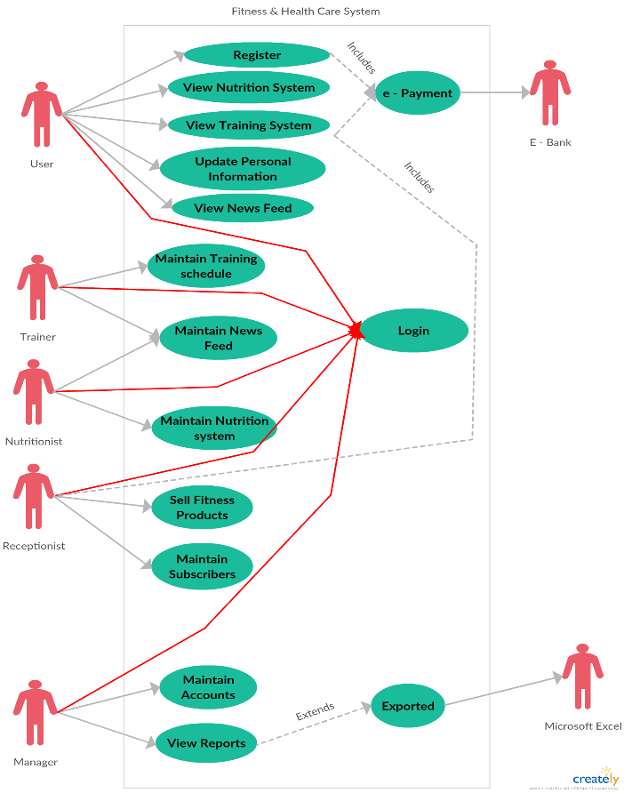

Figure 4: A Use Case Diagram for Fitness & Health care System

**VII. CONCLUSIONS**

Software Requirements Engineering is a very critical process for software systems. This is particularly valid for Fitness & Health care systems. With the increasing rate technology development, the need for Fitness and health care seems to be essential. Here comes the importance of the engineering process that should ensure an implementation of the system to meet the requirements of this need, & to avoid future fatal consequences when the system is implemented. The output of the requirement analysis process─ system requirements─ is used as an input and a description for all ultimate processes including design, testing, and maintenance. If this input has flows or is incomplete, the design probably will fail.

This paper presents a thorough analysis of Fitness & Health care system requirements using the requirements engineering process. Both functional and non-functional requirements are discussed & investigated. Furthermore, only the use case diagram was explained and drawn, and to get better insight into the business processes, the problem, and the system, a number of graphical notations are used. This will help developers to further understand and analyze the requirements as needed.

**REFERENCES**

[1] <http://www.mckinsey.com/industries/healthcare-systems-and-services/our-insights/engaging-consumers-to-manage-health-care-demand>

[2] <http://technologysocietylazys.blogspot.com/>

[3] <http://www.independent.co.uk/life-style/health-and-families/health-news/research-suggests-being-lazy-is-a-sign-of-high-intelligence-a7176136.html>

[4] <https://www.interaction-design.org/literature/book/the-encyclopedia-of-human-computer-interaction-2nd-ed/requirements-engineering>

[5]<https://www.mindtools.com/pages/article/newPPM_77.html>

[6]<http://www.cs.ccsu.edu/~stan/classes/cs530/notes14/04-requirements.html>

[7] <https://www.smartdraw.com/use-case-diagram/>